UPPER BANN U3A
Incident Report Form

Please note that this form is to be filled in by the group convenor or group leader and should be retained on file by the IJ3A committee in case of a claim and for a period of three years even if a claim appears unlikely.

A YOUR DETAILS

U3A

Name | Position
Email | Telephone
Address

 | Postcode

B INCIDENT DETAILS

Date of incident Time of incident
Where did the incident occur?
Please state the reason for the injured person or damaged property being there
Please describe the circumstances of the incident Attach a sketch or photograph(s) if appropriate

C PARTICULARS OF PERSON(S) INVOLVED IN THE INCIDENT (continue on a blank page if necessary)

Name Email
Address
Postcode Telephone
Was he/she a member of your U3A on the date of the incident?
Name Email
Address
Postcode Telephone
Was he/she a member of your U3A on the date of the incident?

Sections D and E are to be completed for any incident involving injury.

D PARTICULARS OF THE INJURED PERSON(S) (continue on a blank page if necessary)

Name Email
Address
Postcode Telephone
Was he/she a member of your U3A on the date of the incident?
Name Email
Address
Postcode Telephone
Was he/she a member of your l.)3A on the date of the incident?

E PARTICULARS OF INJURY

Describe the injury/injuries

Immediate action taken
Treatment at the scene
Admission to hospital
Ongoing medical treatment
2
Section F is to be completed for any incident involving damage to property
F DETAILS OF DAMAGED PROPERTY

Describe damage caused
Estimated cost of repair or replacement
Name of owner of damaged property
Email | Telephone
Address
 | Postcode

The remaining sections are to be completed for al! incidents

G NAME AND CONTACT DETAILS OF ANY WITNESSES TO THE JNCIDENT

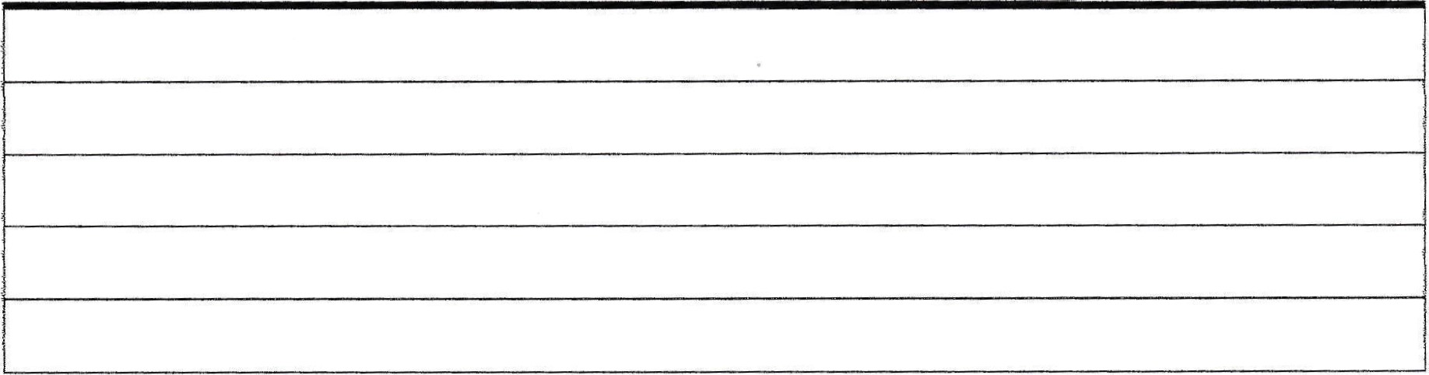
H DECLARATION

i/We declare that to the best of my/our knowledge and belief ail the foregoing particulars are true and correct in all respects.
Signed Group Convenor /Group Leader Date

Signed Injured Person /Property Owner Dated
Or Witness to the Incident
3

or
Please return completed Incident Report Form to the Convenor for all Groups on:- ubu3a.groups@gmail.com

